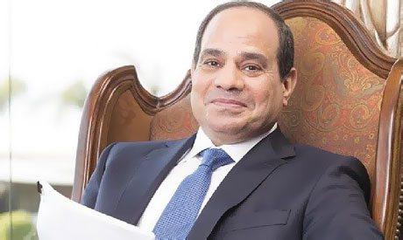

By Kristen Twitty

Ruling of Egypt:

It is shared between the President and the Prime Minister

President:

**Abdel Fattah el-Sisi**

-He was sworn into office as president on June 8th, 2014.

Prime Minister:

**Ibrahim Mahlab**

-He was elected in 2014.

**Legislative Branch:**

**-The Egyptian parliament is bicameral and consists of the Majlis El-Shaab (the People’s assembly) and the Majlis El-Shourah (The Advisory Council)**

**The People’s Assembly:**

**-444 directly elected members & 10 members appointed by the president. They serve for 5 year term.**

**The Advisory Council:**

**-140 members (70 of which are nominated by the president)**

**-Egypts consultative council**

**Egypt is divided into 27 Governates**

-Each Governate has a governer chosen by the president.

-Each Governate has their own local government.

**27 governorates** : (muhafazat, singular - muhafazat); Ad Daqahliyah, Al Bahr al Ahmar (Red Sea), Al Buhayrah, Al Fayyum, Al Gharbiyah, Al Iskandariyah (Alexandria), Al Isma'iliyah (Ismailia), Al Jizah (Giza), Al Minufiyah, Al Minya, Al Qahirah (Cairo), Al Qalyubiyah, Al Uqsur (Luxor), Al Wadi al Jadid (New Valley), As Suways (Suez), Ash Sharqiyah, Aswan, Asyut, Bani Suwayf, Bur Sa'id (Port Said), Dumyat (Damietta), Janub Sina' (South Sinai), Kafr ash Shaykh, Matruh, Qina, Shamal Sina' (North Sinai), Suhaj

**The Constitution of the Arab Republic of Egypt**

**-It was Adopted in 1971**

**-It Declared Egypt as an Arab Republic with a democratic system**

**-It Declared there will be a president, and elections every six years.**

(n.d.). Retrieved March 23, 2015, from http://www.algemeiner.com/wp-content/uploads/2014/05/el-sisi.jpg

Conventional Long Form Country Name: Arab Republic of Egypt

**Government in Egypt**